**Project Development Phase**

**Performance Testing**

|  |  |
| --- | --- |
| Date | 18 May 2023 |
| Team ID | NM2023TMID01052 |
| Project Name | Project - “AI Enabled Car Parking Using OpenCV” |

**Model Performance Testing:**

Project team shall fill the following information in the model performance testing template.

|  |  |  |  |
| --- | --- | --- | --- |
| **S.No** | **Parameter** | **Values** | **Screenshot** |
|  | Model Summary | In this model, it has **Data Acquisition**, **Object Detection, Vehicle Tracking**, **Parking Space Detection** and **Occupancy detection** through sensors. | Mentioned below |
|  | Accuracy | Training Accuracy – **92%**  Validation Accuracy -**94%** | Mentioned below |
| 3. | Confidence Score (Only Yolo Projects) | Class Detected   Confidence Score –  **“if count < 900”** | Mentioned below |

**1. Model Summary**

* **Data Acquisition**

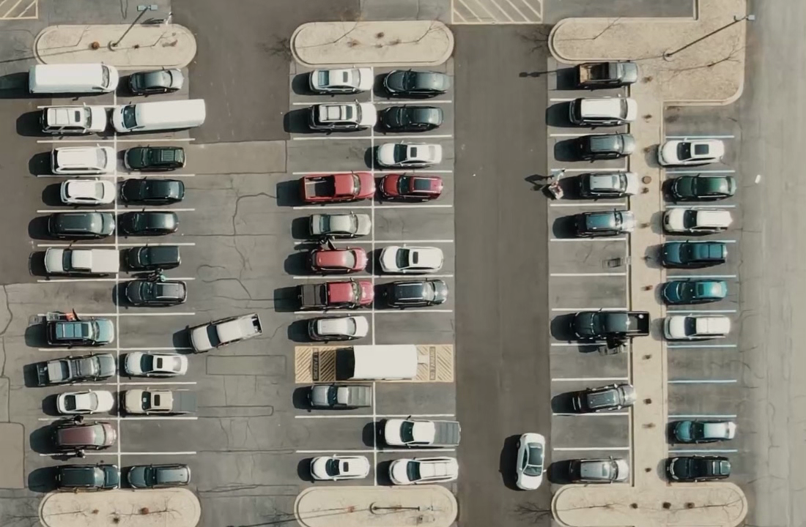

* **Object Detection and Vehicle Detection**

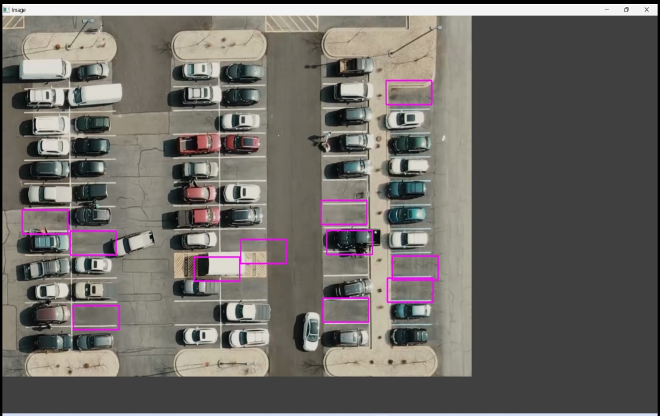

* **Parking Space Detection and occupancy detection**

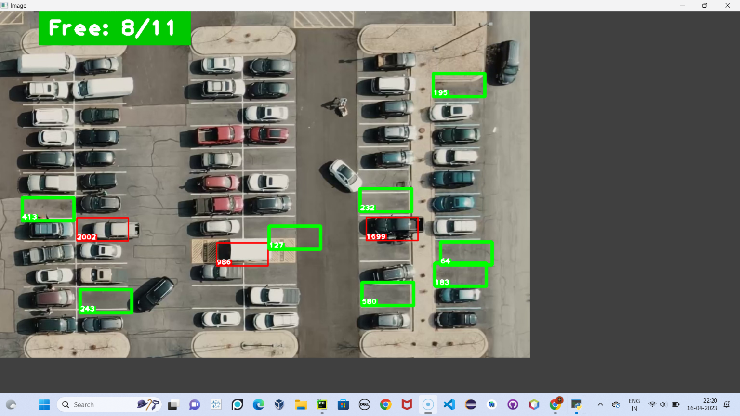

**2. Accuracy**

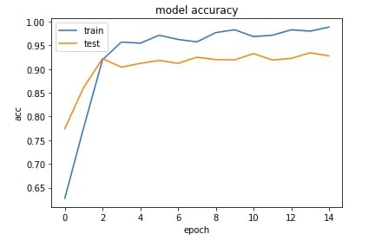

1. **Confidence Score**

* **Class Detected**

cap = cv2.VideoCapture('carPark.mp4')

with open('CarParkPos', 'rb') as f:

    posList = pickle.load(f)

width, height = 107, 48

cap = cv2.VideoCapture('carPark.mp4')

width, height = 103, 43

with open('polygons', 'rb') as f:

    posList = pickle.load(f)

* **Confidence Score**

if count < 900:

            color = (0, 200, 0)

            thic = 5

            spaces += 1

        else:

            color = (0, 0, 200)

            thic = 2

 if count < 900:

            color = (0, 255, 0)

            thickness = 5

            spaceCounter += 1

        else:

            color = (0, 0, 255)

            thickness = 2